**Power BI Assignment 2**

1. Explain the advantages of Natural Queries in PowerBi with an example?

*Ans: Natural Queries in Power BI is an exclusive feature called QnA. This provides the automated analysis options in question format, from the data set loaded inn and supports understanding the data in a simple way, without/ prior working on analysis of the data, manually.*

*This could be navigated by double clicking on the canvas- below snip is for an instance from Power BI desktop showcasing the Natural query dilog box. We could either opt the automated option as highlighted in Blue or search by natural English lang as just speaking to a person in the Ask a question about your data* field.*

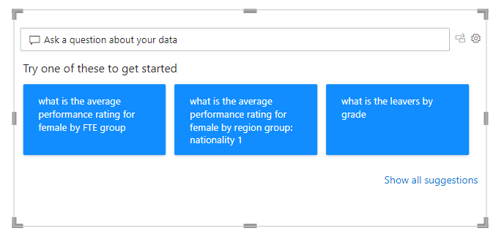

1. Explain Web Front End(WFE) cluster from Power BI Service Architecture?

*Ans: The Front end cluster of Power BI is commonly known as Web front end cluster, which connects the client and back end. The front-end services handle the initial connection and Azure Active Directory client authentication.*

*User IDs are kept in the Azure Active Directory. After authentication, user requests are routed through Azure Traffic Manager to the closest data center. The WFE is vital for Back end clustering process.*

1. Explain Back End cluster from Power BI Service Architecture?

*Ans: Visualizations, datasets, storage, reports, data connections, data updating, and other Power BI interactions are handled by the Back end cluster of Power BI services. A web client can only directly interface with Azure API Management and Gateway Role on the backend. These two parts are in charge of routing, load balancing, authentication, and authorization.*

1. What ASP.NET component does in Power BI Service Architecture?

*Ans: ASP.net in Power BI service supports to publish the report in Web. This is embed file involving iframe code to run web app and interact with the report*.

1. Compare Microsoft Excel and PowerBi Desktop on the following features:
   1. ***Data import*** *– Files format are in common btw PBi and Excel. However there are vast options at PBI to load inn the data.*
   2. ***Data transformation****- Power query is common yet the data transformation has wider options at PBI.*
   3. ***Modeling****- Power Pivot is common in both but PBI stands out, when compared due to it’s flexibility.*
   4. ***Reporting****- Power View, PBI with no doubt has numerous visuals and could be obtained from 3rd party- get more visuals* in support to reporting task. Excel has basic set of Visuals.*
   5. ***Server Deployment****- PBI (Deployment pipeline)is the easiest and to go comparative to Excel Server deployment features.*
   6. ***Convert Models****- Excel and PBI has Power pivot and power charts – however Power BI has got faster effect on models.*
   7. ***Cost****- PBI licenses are in multiple range and cost involved- Desktop, Service, Pro, Premium and Excel is web app used without any versions as PBI.*

1. List 20 data sources supported by Power Bi desktop.
   1. *Excel*
   2. *XML*
   3. *CSV/TXT*
   4. *Json*
   5. *Folder*
   6. *PDF*
   7. *Sql server DB*
   8. *Oracle DB*
   9. *SAP HANA DB*
   10. *IBM Db2 DB*
   11. *Amazon Redshift*
   12. *Azure Sql DB*
   13. *PBI Data sets*
   14. *Google Analytics*
   15. *Web*
   16. *Sharepoint list*
   17. *Python Script*
   18. *Dataverse*
   19. *Google sheets*
   20. *Data flow*
   21. *Parquet*